*LA2 Project Report*

**CROP YIELD PREDICTION**

*Submitted in**partial fulfilment of the requirements for the LA2 component of the*

*Subject PE data Science using Python (Semester – 5)*

**Bachelor of Engineering**

**in**

**Computer Science and Engineering**

for the **Academic Year: 2024-25**

*Submitted by*

**SANJAY PATIL M 1NT22CS180**

**PHILIP JOHN 1NT22CS130**

Under the Guidance of

**Dr. Vani Vasudevan**

Professor

Dept. of Computer Science and Engineering

**Table of contents:**

**Title Pg No**

**1.Problem definition and understanding ……………………………. 1 – 3**

**1.1 Problem Statement**

**1.2 Dataset Overveiw**

**1.3 Features in the Dataset**

**1.4 Objective**

**1.5 Evaluation Metric**

**2.Data Collection and Exploration …………………………………… 4 - 5**

**2.1 Data Source**

**2.2 Data cleaning and pre-processing**

**2.3 Assumptions**

**2.4 Feature scaling**

**3.Code Snippets………………………………………………………….6-10**

**4.Modelling and analysis……………………………………………….. 11-13**

**3.1 Feature Engineering**

**3.2 Model Selection and training**

**3.3 Model evaluation**

**3.4 Model Interpretation**

**3.5 Model Improvement strategies**

**5.Conclusions and results.………………………………………………. 14**

**6.References …………………………………………………………….. 15**

**Chapter 1: Problem Definition and Understanding**

**1.1 Problem Statement**

The problem addressed in this study is the accurate prediction of crop yields based on various environmental, soil, and climatic factors. Given the complexity of agricultural systems, where multiple interrelated factors such as temperature, rainfall, soil type, and crop type influence the yield, the goal is to develop a machine learning model that can predict crop yields with high accuracy. This model can assist farmers, agronomists, and policymakers in optimizing agricultural practices, improving food security, and managing resources efficiently.

**1.2 Dataset Overview**

The dataset used in this study contains various features related to soil properties, weather conditions, and crop types. These features include both numerical (e.g., temperature, rainfall, soil pH) and categorical (e.g., crop type, soil class) data. The dataset is sourced from government records, weather databases, and soil health reports, providing a comprehensive set of inputs for modeling crop yield.

**1.3 Features in the Dataset**

The key features in the dataset include:

Numerical Features:

* Temperature: Average temperature for the growing season.
* Rainfall: Total rainfall during the crop growing period.
* Soil pH: Measure of soil acidity/alkalinity.
* Soil moisture index: A derived feature representing soil moisture levels.

Categorical Features:

* Crop Type: Type of crop grown (e.g., wheat, rice).
* Soil Class: Type of soil (e.g., loamy, sandy).

Derived Features:

* Temperature anomalies: Deviations from the average temperature, helping identify potential stress conditions for crops.
* Rainfall variations: Changes in rainfall patterns over time.

**1.4 Objective:**

The objective of this research is to build a robust machine learning model, primarily using the Random Forest algorithm, to predict crop yields based on the environmental, soil, and climatic features. The model will aim to help farmers, agronomists, and policymakers make data-driven decisions to optimize crop productivity and resource allocation, thereby contributing to food security and sustainable farming practices.

**1.5 Evaluation Metric:**

The performance of the machine learning models is evaluated using the following metrics:

* Mean Absolute Error (MAE): Measures the average magnitude of the errors between predicted and actual values.
* Root Mean Square Error (RMSE): Provides a measure of the error magnitude, with higher penalties for larger errors.
* R-squared (R²): Indicates the proportion of the variance in the dependent variable that is predictable from the independent variables. An R² value closer to 1 indicates a better fit.

**Chapter 2: Data Collection and Exploration**

**2.1 Data Source:**

The data is collected from multiple agricultural and environmental sources. This includes government records (e.g., crop production statistics), weather databases (e.g., historical rainfall, temperature data), and soil health reports (e.g., pH, nutrient content of soil). These sources provide the raw data needed for the machine learning model, covering both numerical and categorical features that are essential for predicting crop yield.

**2.2 Data Cleaning and Pre-processing:**

Explanation: The preprocessing stage is crucial for handling raw data and making it suitable for machine learning models.

* Handling Missing Values: Missing data for certain features is addressed by imputing values based on available information. For example, missing temperature data is predicted using regression models based on other features such as rainfall, humidity, and region-specific data.
* Feature Engineering: New features like "Season Type" and "Rainfall Intensity" are created to add more context to the data. This allows the model to better capture the complexities of the relationships between various factors like rainfall and yield.
* Encoding Categorical Variables: Categorical features such as CropType and SoilType are encoded numerically through techniques like one-hot encoding, making them understandable by machine learning models.

**2.3 Assumptions**

Explanation: Assumptions guide the model’s approach to data handling:

Missing data for certain features is assumed to be missing at random and is handled by statistical methods.

The relationships between input variables (like temperature, rainfall, soil type) and crop yield are assumed to be significant and can be learned by machine learning algorithms.

We assume that the available data can generalize to unseen regions or conditions, allowing the model to predict crop yield effectively for new cases**.**

**2.4 Feature Scaling**Explanation: Feature scaling is a technique used to standardize the range of independent variables or features. It ensures that no single feature dominates others due to differences in scale.

* Min-Max Scaling: Used to scale numerical features like Temperature, Rainfall, and FertilizerUsage to a range between 0 and 1. This makes the model less sensitive to large differences in feature magnitude.
* Importance for Model Performance: Scaling is crucial for algorithms that use distance metrics, like Support Vector Machines or K-Nearest Neighbors. However, for tree-based models (like Random Forest), scaling may not be necessary as these algorithms are not sensitive to the magnitude of the features.

Feature scaling is a data pre-processing technique that involves scaling numerical features to a common range. This is often necessary because machine learning algorithms can be sensitive to the scale of features. For instance, features with larger ranges can dominate the learning process, leading to biased models.

**Why is Feature Scaling Important?**

1. **Improved Model Performance:**
   * **Gradient Descent:** Algorithms like gradient descent converge faster when features are on a similar scale.
   * **Distance-Based Algorithms:** Algorithms like K-Nearest Neighbors (KNN) and Support Vector Machines (SVM) rely on distance calculations. Scaling ensures that features contribute equally to distance calculations.
2. **Better Feature Interpretation:**
   * Scaling can make it easier to interpret the coefficients of linear models.

StandardScaler is a popular technique for feature scaling. It standardizes features by removing the mean and scaling to unit variance. The formula for standardizing a feature x is:

z = (x - mean) / std

where:

* z is the standardized value
* x is the original value
* mean is the mean of the feature
* std is the standard deviation of the feature

Fig 2.28

**CHAPTER 3: Code Snippets**

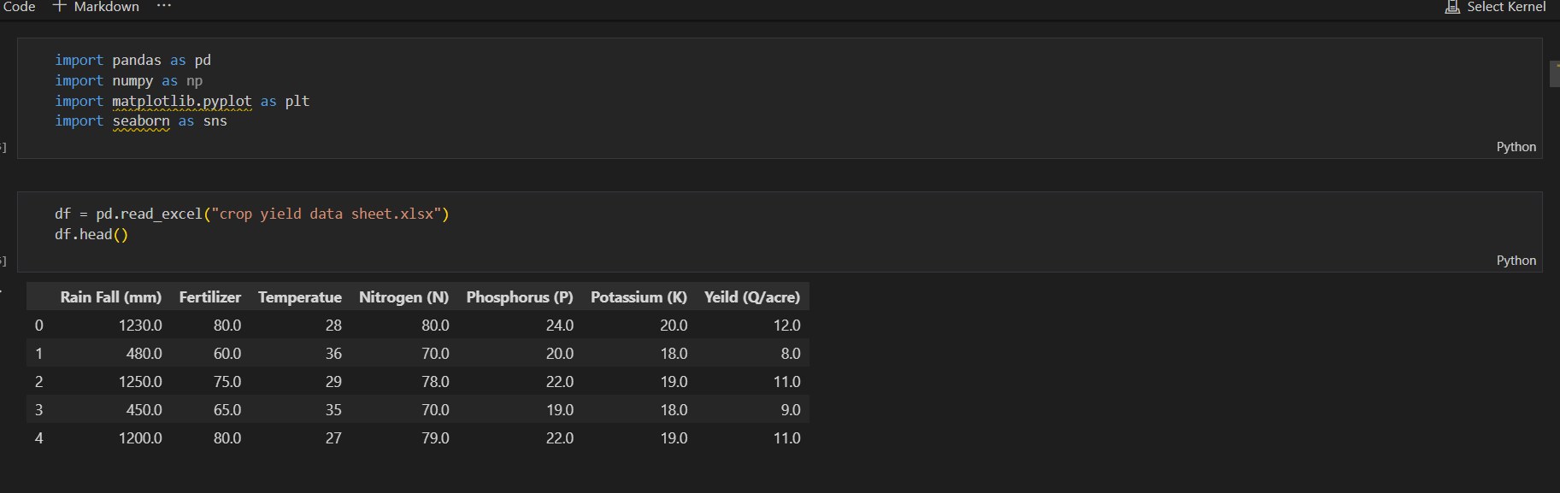

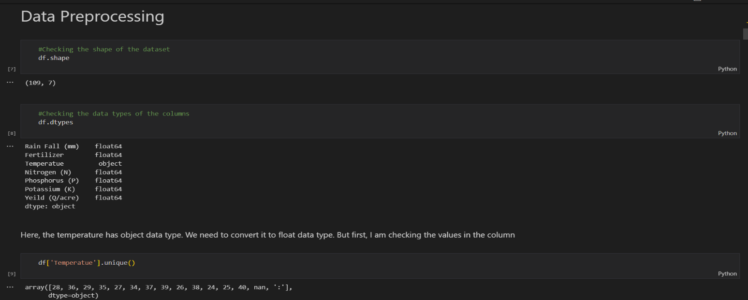

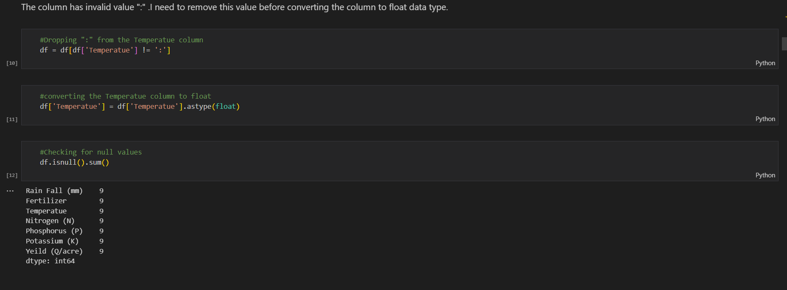

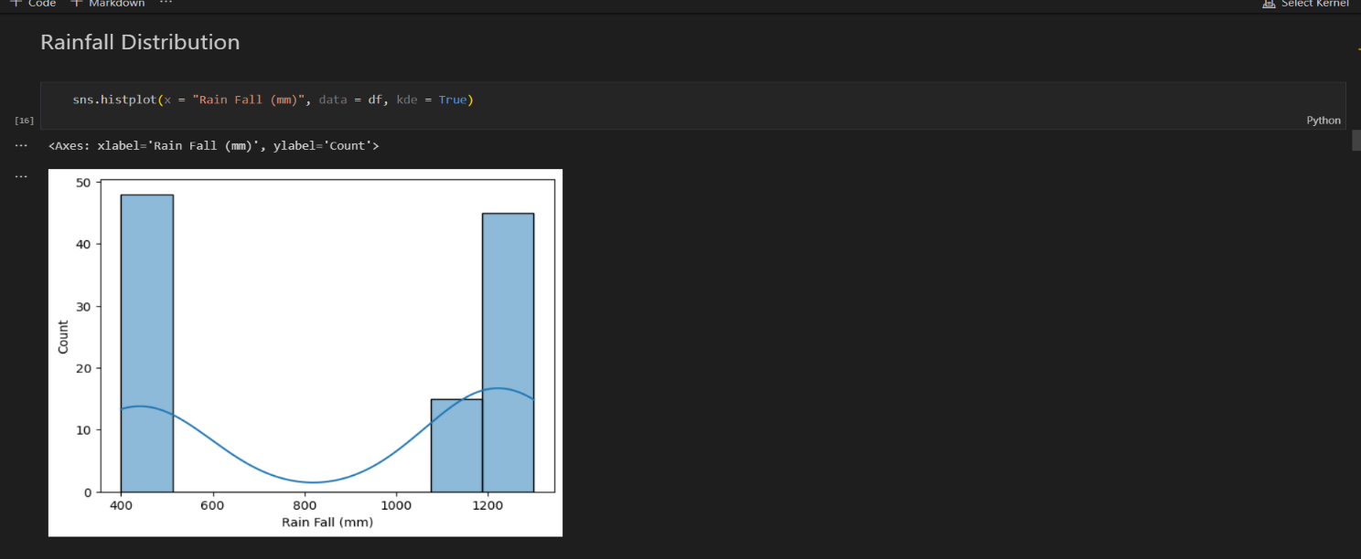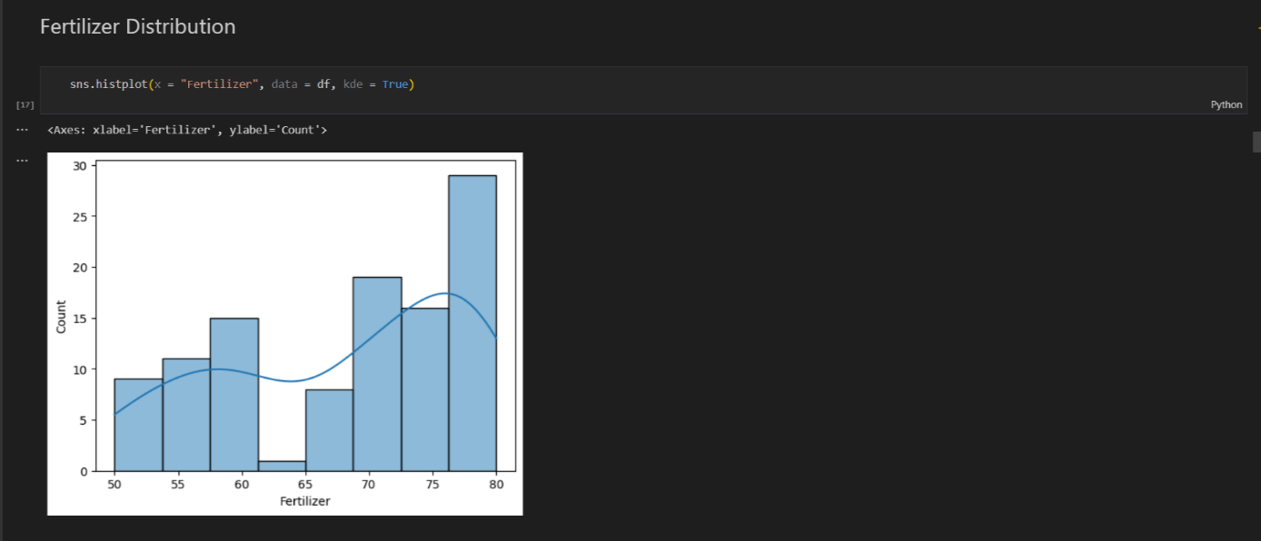

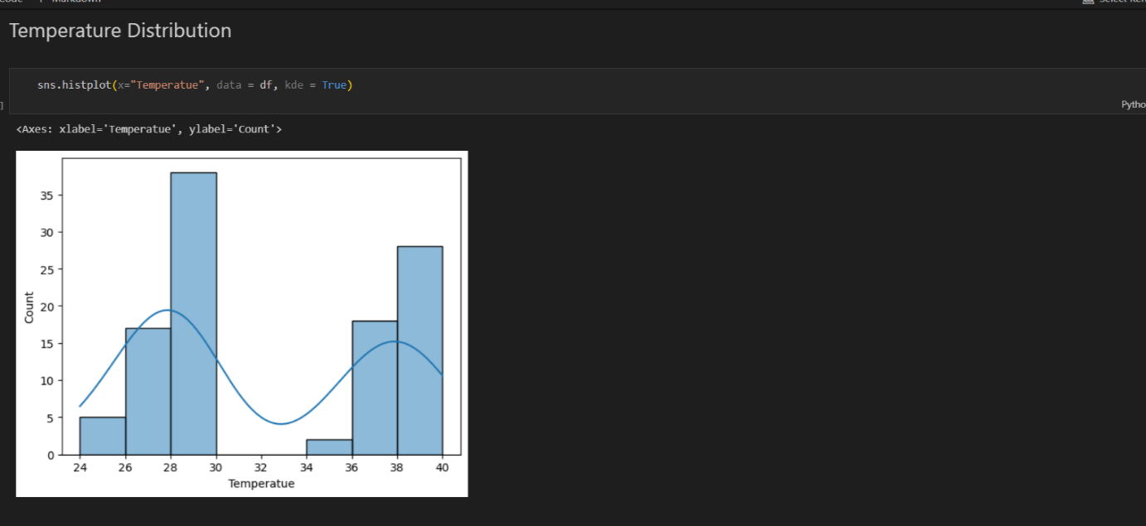

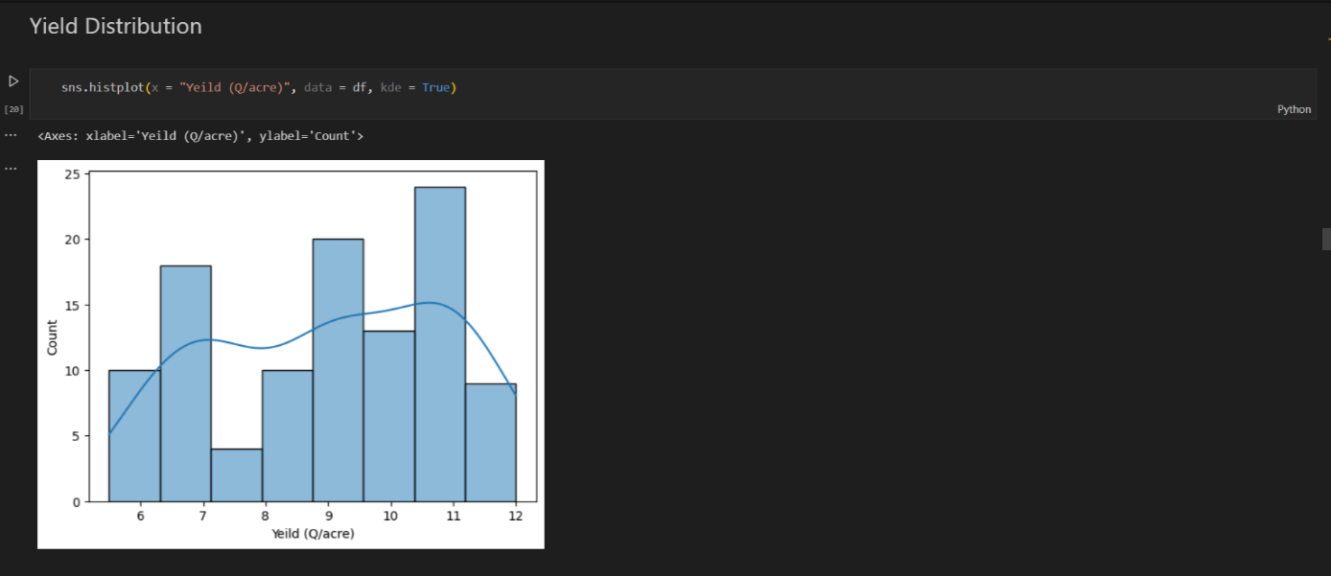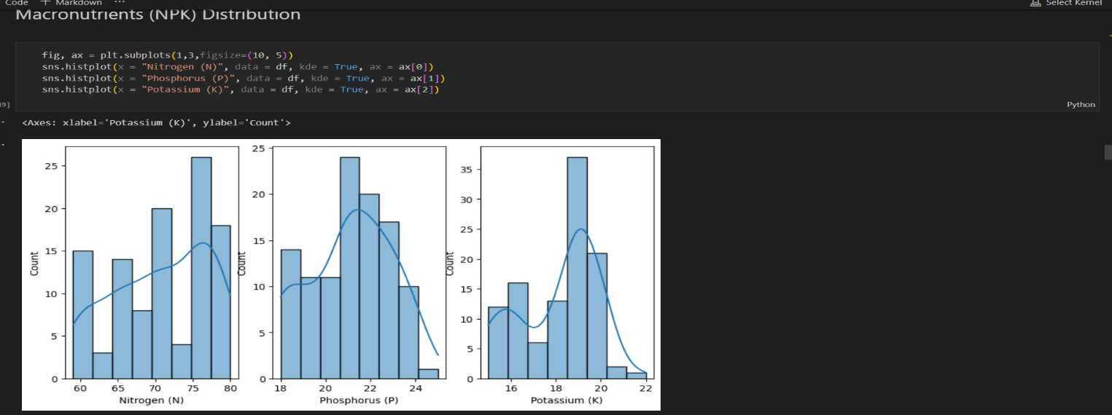

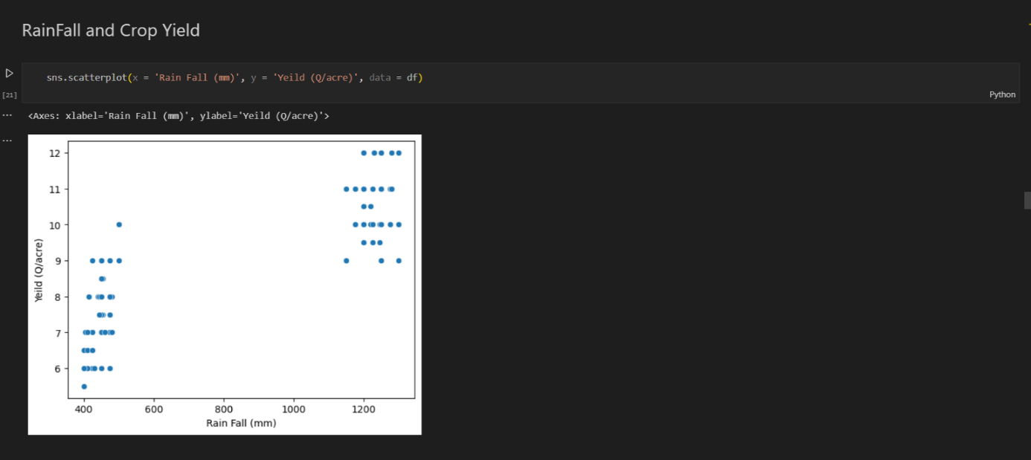

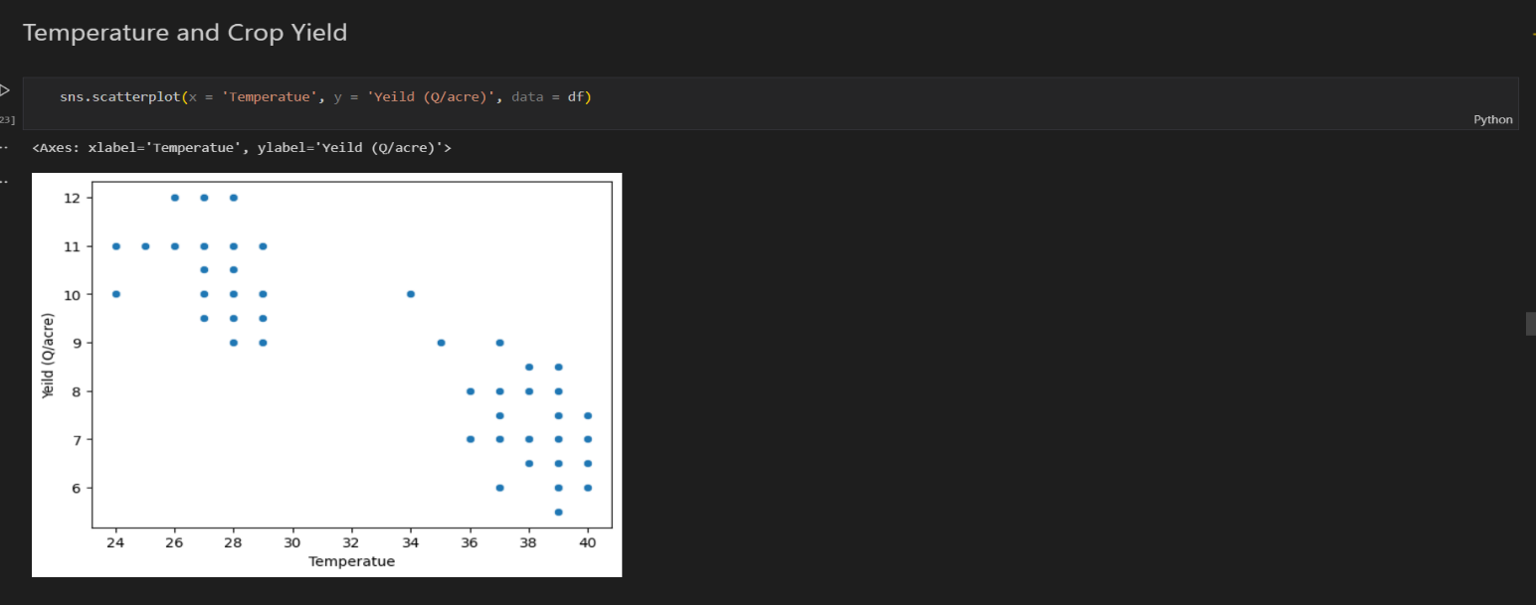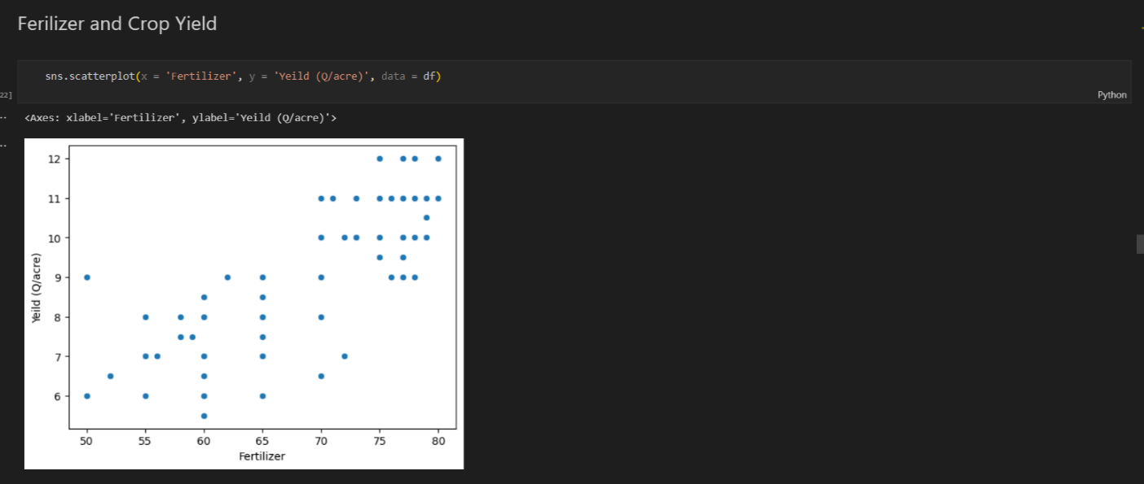

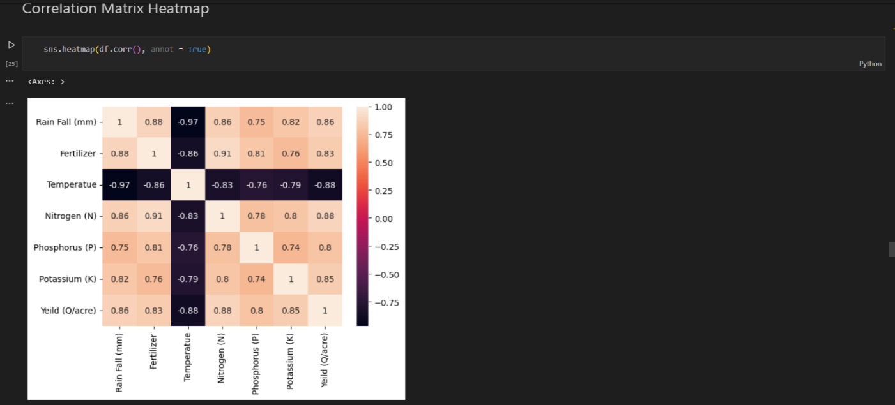

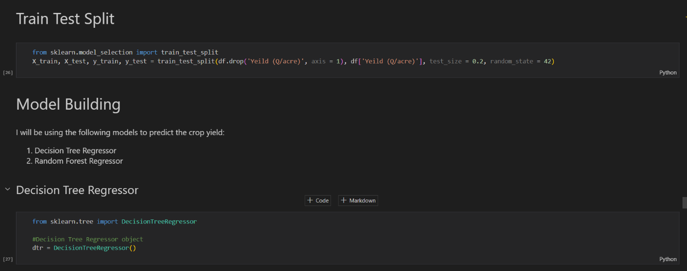

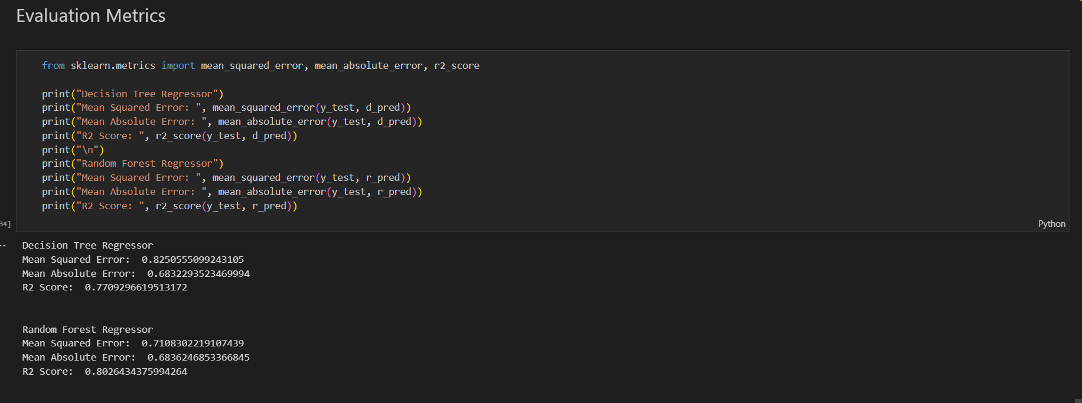

**CHAPTER 4 : Modeling and Analysis**

**3.1 Feature Engineering:**

Feature engineering involves transforming raw data into meaningful features that can improve model performance. This is a crucial step in machine learning, as well-engineered features can make algorithms more effective. Some common techniques used include:

* Creation of Interaction Terms: Combining two or more features to create new ones that might provide additional predictive power.
* Binning: Grouping numerical features into categories (e.g., dividing age into ranges like "0-18", "19-35", etc.).
* Encoding Categorical Features: Converting categorical data into numerical format using methods like one-hot encoding or label encoding.
* Handling Missing Data: Missing values can be handled by imputing with statistical measures (mean, median, mode) or predictive models, or by removing rows/columns with too many missing values.

Technical Justification:

Feature engineering is essential for improving the ability of machine learning models to recognize patterns. For example, creating new features such as "season type" based on temperature could reveal patterns that help a model make more accurate predictions. The success of any model depends heavily on how well the input features are prepared.

**3.2 Model Selection:**

Selecting the right model depends on the problem at hand. For regression tasks (like predicting crop yield), models such as Linear Regression, Random Forest Regressor, and Gradient Boosting Machines are commonly used. Each model has its strengths, and the choice depends on:

* Linear models are simple and work well when the relationship between features and the target is approximately linear.
* Random Forest handles complex, non-linear data by averaging over many decision trees.
* Gradient Boosting focuses on combining weak learners to make more accurate predictions.

Technical Justification:

Training involves feeding the model with the data and using an optimization algorithm (like gradient descent for linear regression) to minimize the error between predicted and actual values. Model selection should be based on the problem's complexity and the model's ability to generalize to new data.

**3.2 Model Training:**

Selecting the right model depends on the problem at hand. For regression tasks (like predicting crop yield), models such as Linear Regression, Random Forest Regressor, and Gradient Boosting Machines are commonly used. Each model has its strengths, and the choice depends on:

* Linear models are simple and work well when the relationship between features and the target is approximately linear.
* Random Forest handles complex, non-linear data by averaging over many decision trees.
* Gradient Boosting focuses on combining weak learners to make more accurate predictions.

Technical Justification:

Training involves feeding the model with the data and using an optimization algorithm (like gradient descent for linear regression) to minimize the error between predicted and actual values. Model selection should be based on the problem's complexity and the model's ability to generalize to new data.

**3.3 Model Evaluation:**

Once the model is trained, it’s essential to evaluate its performance. Evaluation metrics for regression models include:

* R-squared (R²): Measures how well the model explains the variance of the target variable.
* Mean Absolute Error (MAE): Average of the absolute differences between the predicted and actual values.
* Mean Squared Error (MSE): Measures the average squared differences between the predicted and actual values, which penalizes larger errors more heavily.

Technical Justification:

Evaluating the model’s performance helps ensure it generalizes well to unseen data. If the model performs poorly, it may be overfitting or underfitting, and adjustments will be necessary (e.g., tuning hyperparameters, adding or removing features).

**3.4 Model Interpretation:**

Model interpretation is the process of understanding how a model makes predictions. This is particularly important for decision-making and ensuring that the model’s predictions are based on reasonable factors. Techniques for interpreting models include:

* Feature Importance: Identifying which features most significantly influence the model's predictions.
* Partial Dependence Plots (PDP): Illustrating how the target variable changes with respect to a single feature, keeping others constant.
* SHAP values: Quantifying each feature's contribution to a particular prediction.

Technical Justification:

Understanding the "why" behind a model's predictions ensures transparency and trust in its outcomes, especially for stakeholders in areas like agriculture, healthcare, or finance. It helps ensure that decisions made based on model predictions are sound.

**3.5 Model Improvement Strategies:**

There are several strategies to improve the model's performance, such as:

* Hyperparameter Tuning: Optimizing the model’s parameters (e.g., learning rate, number of trees in Random Forest) to improve accuracy.
* Ensemble Methods: Combining predictions from multiple models (e.g., stacking, bagging, boosting) to improve the overall performance.
* Cross-Validation: Using cross-validation to ensure the model's robustness and reduce overfitting.
* Regularization: Techniques like L1 or L2 regularization help prevent overfitting by penalizing large weights.

Technical Justification:

Improvement strategies like hyperparameter tuning can significantly increase model performance. By optimizing how the model is trained or by combining predictions from multiple models, we can make more accurate predictions and ensure that the model performs consistently across different datasets.

**Chapter 5 : Conclusion and Results**In this project, we applied various techniques and strategies for modeling and analyzing agricultural data, particularly focusing on crop yield prediction. We started by performing feature engineering, transforming raw data into meaningful features that enhanced the model's ability to learn. This was followed by the model selection and training phase, where different models were considered based on the data type and problem requirements, including linear regression, decision trees, and ensemble methods.

The model evaluation phase highlighted the performance of different models using metrics such as R-squared, MAE, and MSE, ensuring that the models were both accurate and generalized. Model interpretation techniques such as feature importance and SHAP values provided transparency, helping us understand the driving factors behind the predictions and ensuring trust in the model's outputs.

We also implemented model improvement strategies, including hyperparameter tuning and ensemble methods, to further enhance model performance. By optimizing the model and applying strategies like cross-validation, we ensured its robustness and reliability. In particular, logistic regression was implemented as a baseline model, showcasing its simplicity and effectiveness for classification tasks.

Finally, feature selection using Recursive Feature Elimination (RFE) enabled us to focus on the most important features, reducing dimensionality and enhancing the overall model efficiency.

Overall, this process demonstrated the importance of carefully selecting and preparing features, choosing appropriate models, and continuously evaluating and improving the model to achieve reliable and interpretable predictions. This approach is applicable not only in agriculture but in various domains where predictive modeling is essential.

**Chapter 6: References**

1. [**www.kaggle.com**](http://www.kaggle.com)
2. [**www.w3wschools.com**](http://www.w3wschools.com)
3. [**www.gemini.com**](http://www.gemini.com)
4. [**www.analyticsvidhya.com**](http://www.analyticsvidhya.com)
5. [**www.geeksforgeeks.com**](http://www.geeksforgeeks.com)
6. [**www.freecodecamp.org**](http://www.freecodecamp.org)
7. [**www.unifiedtech.com**](http://www.unifiedtech.com)
8. [**www.simplilearn.com**](http://www.simplilearn.com)
9. [**www.sckitlearn.com**](http://www.sckitlearn.com)